20 cys281 lab2

Name: G. kushal bhavani reddy

Roll no:CB.EN.U4CYS21021

**Set-1**

1. Create a file ***“shakespeare.txt”*** and ***“wordsworth.txt”*** that contains the contents as shown below :

**Contents of *shakespeare.txt*:**

“To be ,or not to be :that is the question

All the world ‘s a stage, and all the men and women merely players. They have their exits and their entrances; And one man in his time plays many parts”

**Contents of *wordsworth.txt:***

“[That best portion of a man's life, his little, nameless, unremembered acts of kindness and love.](https://www.azquotes.com/quote/320829)

The mind of man is a thousand time more beautiful than the earth on which he dwells.”

a. Create another File ***“Quotes.txt”*** which has the title as “Famous Quotes “ and contents of ***wordsworth.txt*** followed by ***shakespeare.txt***.

b. Add the following quote “The strongest of all warriors are these two — Time and Patience” to the end of ***Quotes.txt***

c. Display the first line that has the word “time” from sorted contents of ***“Quotes.txt”***

d. Sort the contents of ***Quotes.txt*** and save it in ***newquote.txt***

e. Find the difference between ***quotes.txt*** and ***newquote.txt***

f. Display the number of words in ***newquote.txt*** (Note: Number of lines , characters etc., should not be printed, only number of words)

g. Restrict the write permission for ***newquote.txt***

h.List the processes and the status in your machine right now

i. Display the free hard disk space in your sytem

j. Display the contents of Quotes.txt, omitting any repeated blank lines.

a.

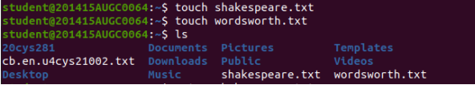

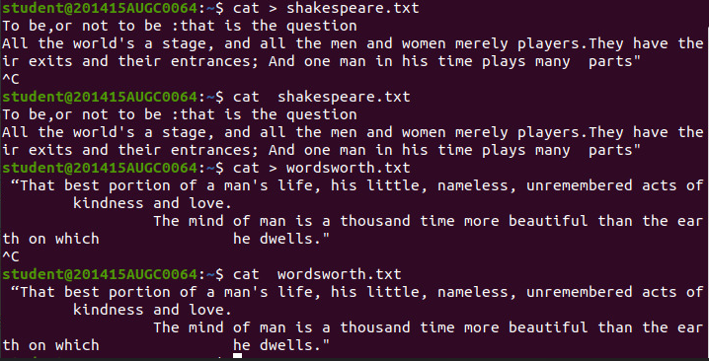

B.

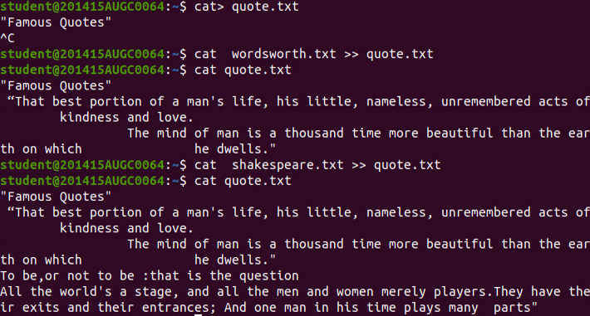

C.



D.



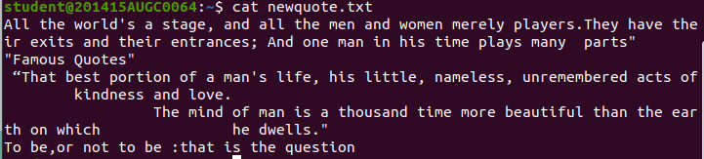

E.

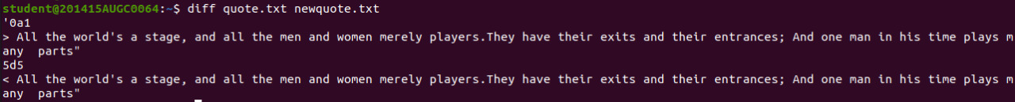

F



G.

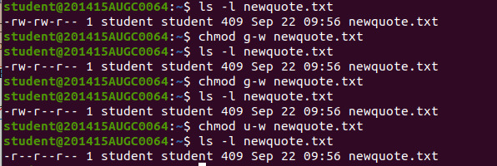

H.

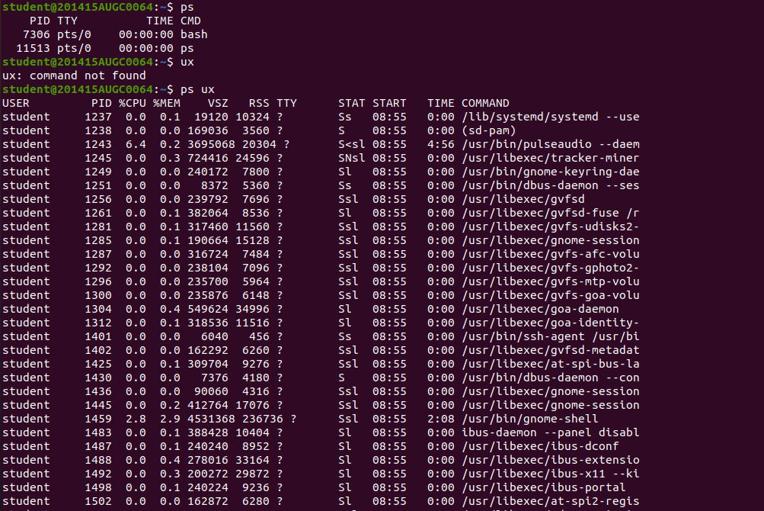

I.

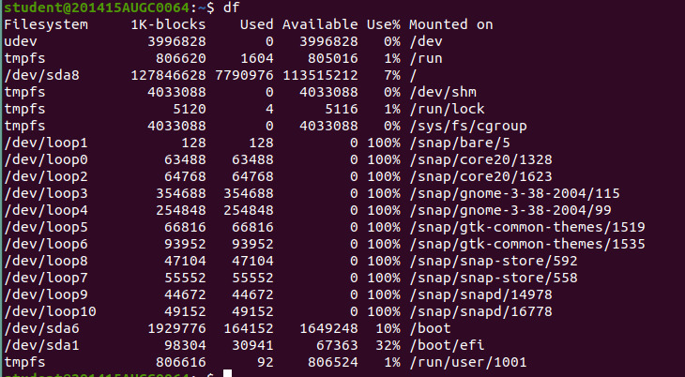

J.

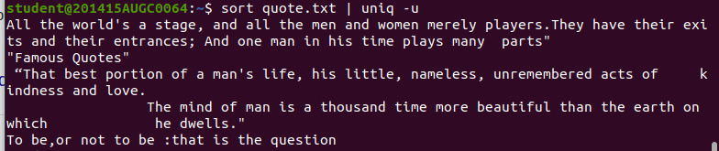

**Set-2**

1.List all the directories only using echo command.

2.List the calendar of September 1752 and explore.

3.Display the time of the day

4.Create a directory by **your rollno e.g cse601**

5. Move the files to appropriate directory

6.List all the directories and files in directory with name as your rollno

7.List the size of **all files (hiddenfiles also)**and folders in desired scale format, directories should not be displayed.

8.Change the permissions of the file DOS.txt give read and write permissions to user and group

9.List all the environment variables and display PATH

10.Change the prompt. And change it back to original prompt.

11.Copy the file /etc/passwd into your home directory.

12. List the usernames and home directory from /etc/passwd in sorted order

ANS:

1.



2.

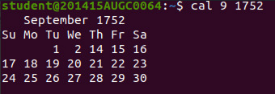

3.

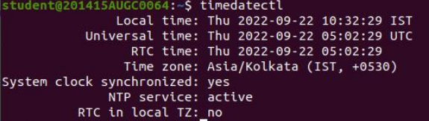

4.



5.

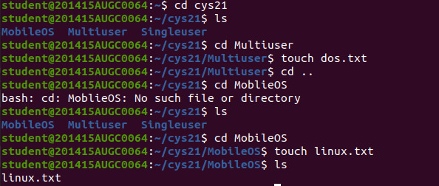

6.



7.

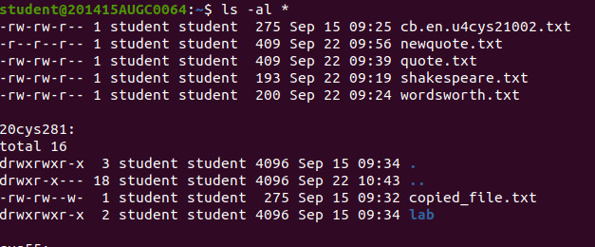

8.



9.

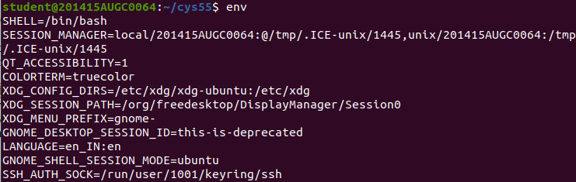

10.

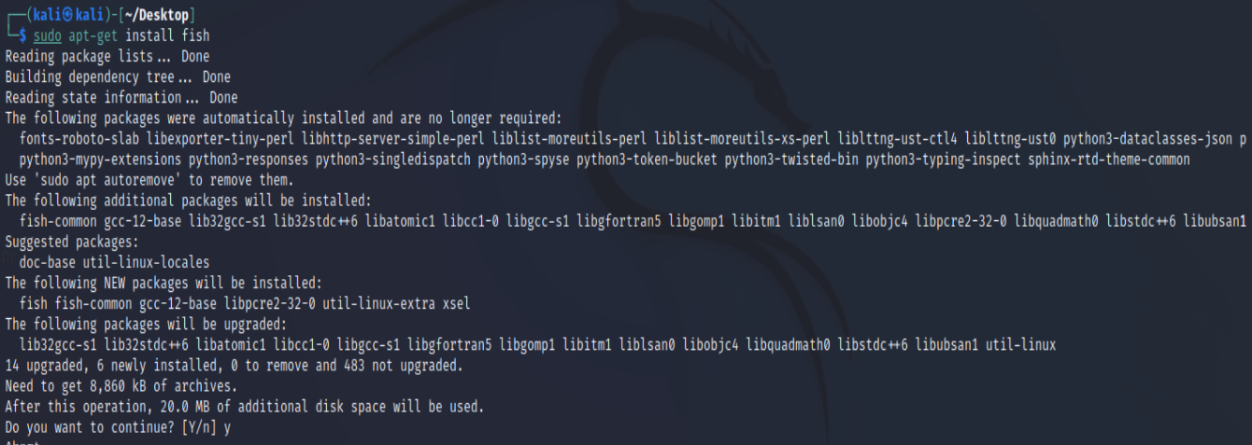

11.



12.

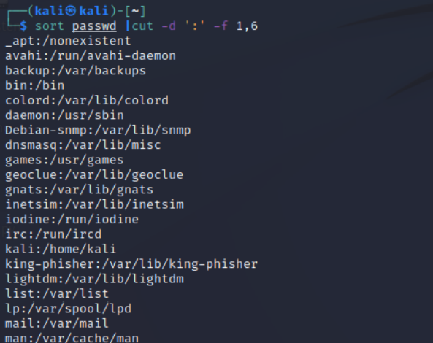

**Set-3**

Type the following commands in the prompt and interpret the output

1. uname -a
2. cat filename(Try this with any existing file in your system)
3. uptime
4. hostname
5. cal
6. w
7. whoami
8. free -h
9. top
10. lsof
11. rm file
12. cp file1 file2
13. touch file
14. ps -ef | grep processname (Interpret purpose of ps, grep and | separately)
15. ifconfig -a
16. hostname -i
17. locate name
18. df -h
19. du -ah
20. man
21. sudo
22. find
23. free
24. kill
25. chown
26. chmod
27. chgrp
28. wc
29. diff
30. uniq

ANS:

1.

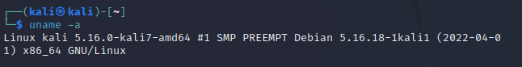

2.



3

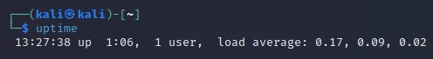

4.



5.

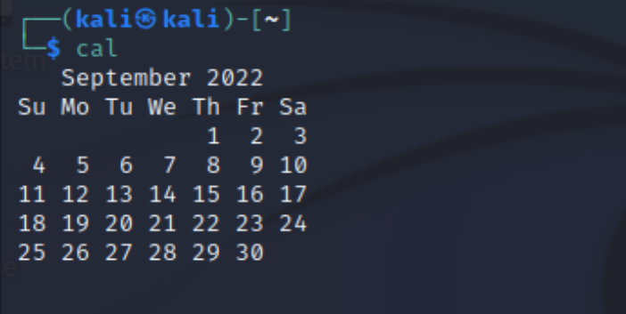

6.

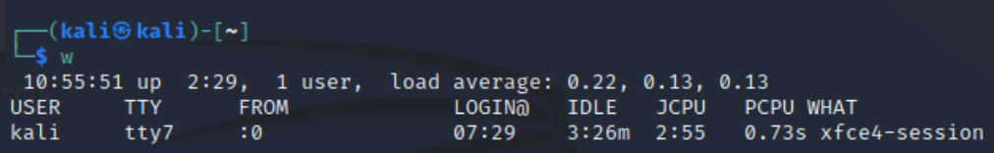

7.

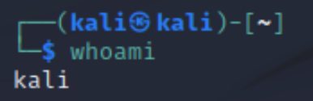

8.

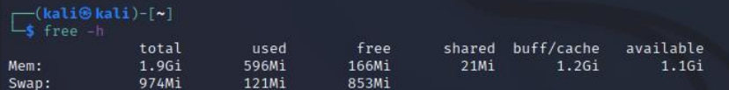

9.

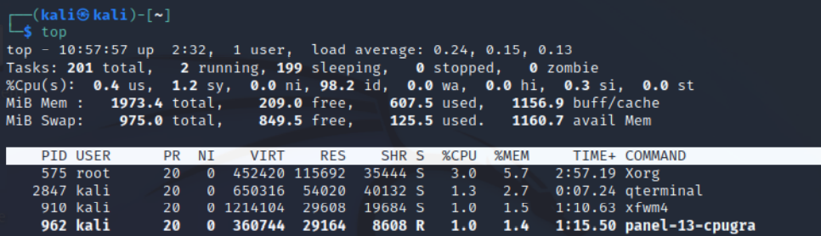

10.

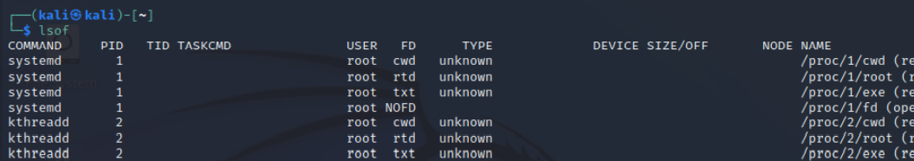

11.



12.

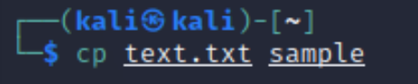

13.

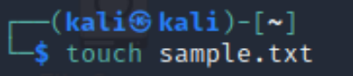

14.

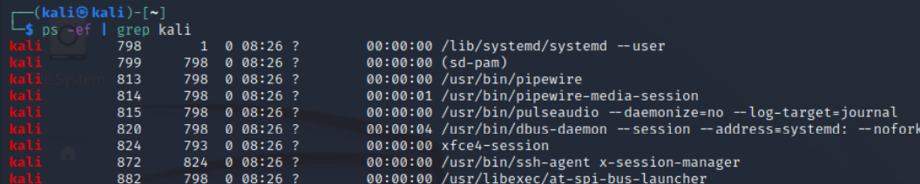

15.

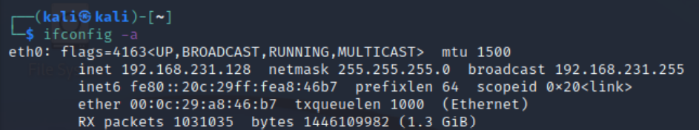

16.

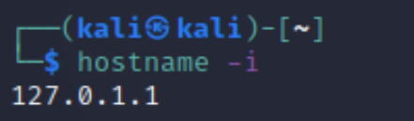

17.

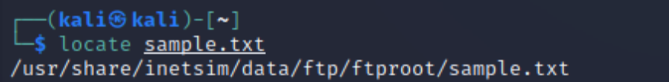

18.

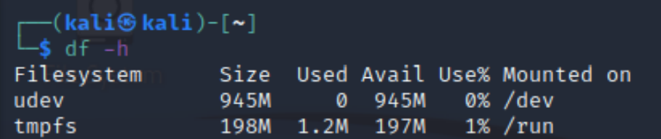

19.

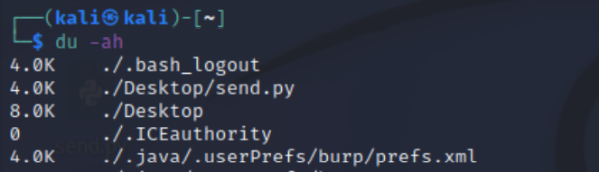

20.

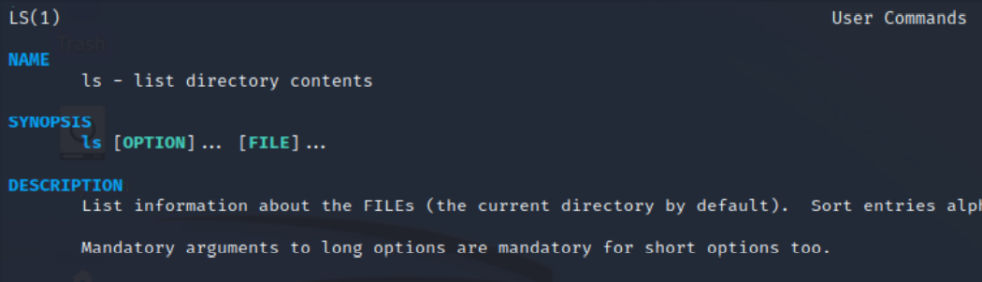

21.

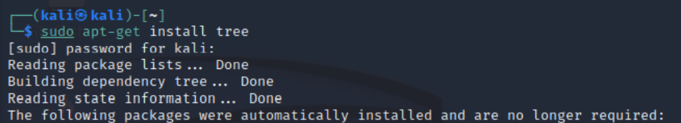

22.

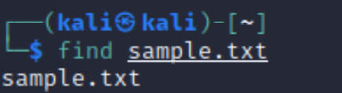

23.

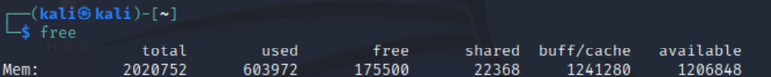

24.

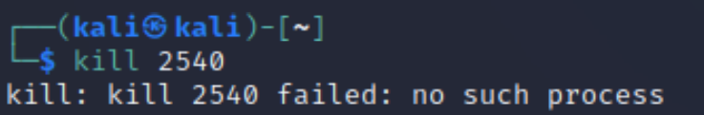

25.

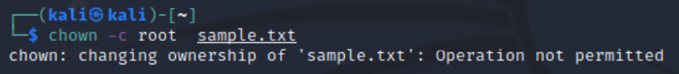

26.

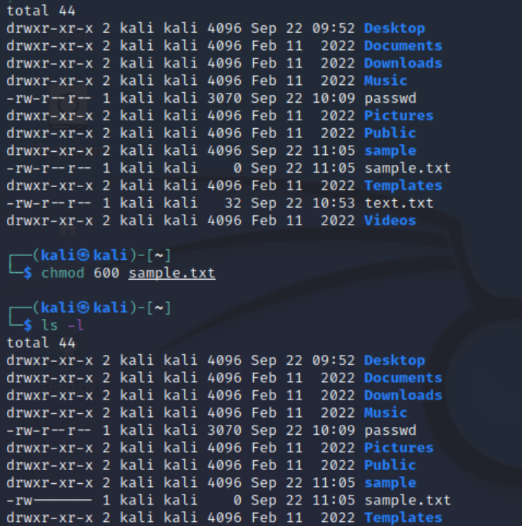

27.

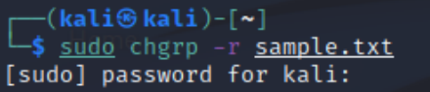

28.

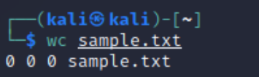

29.

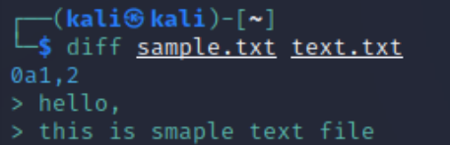

30.

